

**American International University- Bangladesh**

**CSC 3215: Web Technologies**

**CO1 and CO3 Evaluation**

**Project Report**

**Spring 2019-2020**

**Project Title: Gym Management System**

**Section: D**

|  |  |
| --- | --- |
| Student Name | Student Id |
| Masum, Khaled | **16-32538-2** |
| Islam, Sumaiah | **17-33564-1** |
| Nawab, Sakibul Alam | **16-33035-3** |

**Introduction: We are doing this project so that we can manage the information of the people coming into the gym and maintaining their health care. It takes care of all their health information. It also maintains the people's attendance, gym records.**

**Background Study**

<https://projectworlds.in/free-projects/php-projects/gym-management-system-project-in-php/>

<https://www.youtube.com/watch?v=tmu941NzC90&t=200s>

<https://www.youtube.com/watch?v=kogjiUXzn2o&t=158s>

**Requirement Analysis:**

1. **User Category:**

There are 3-types of Users here. They are:

* Super admin
* Member
* Trainer

1. **Feature List:**

In this project the “User Type 1” has the following features:

* Member registration
* Trainer registration
* Equipment registration
* Member list
* Trainer list
* Equipment list
* Package details
* Payment details

In this project the “User Type 2” has the following features:

* View user profile
* Update user profile
* View workout plan
* View diet plan

In this project the “User Type 3” has the following features:

* Check member list
* Check appointment
* Make diet plan
* Make workout plan

**Design:**

Entity relationship diagram:

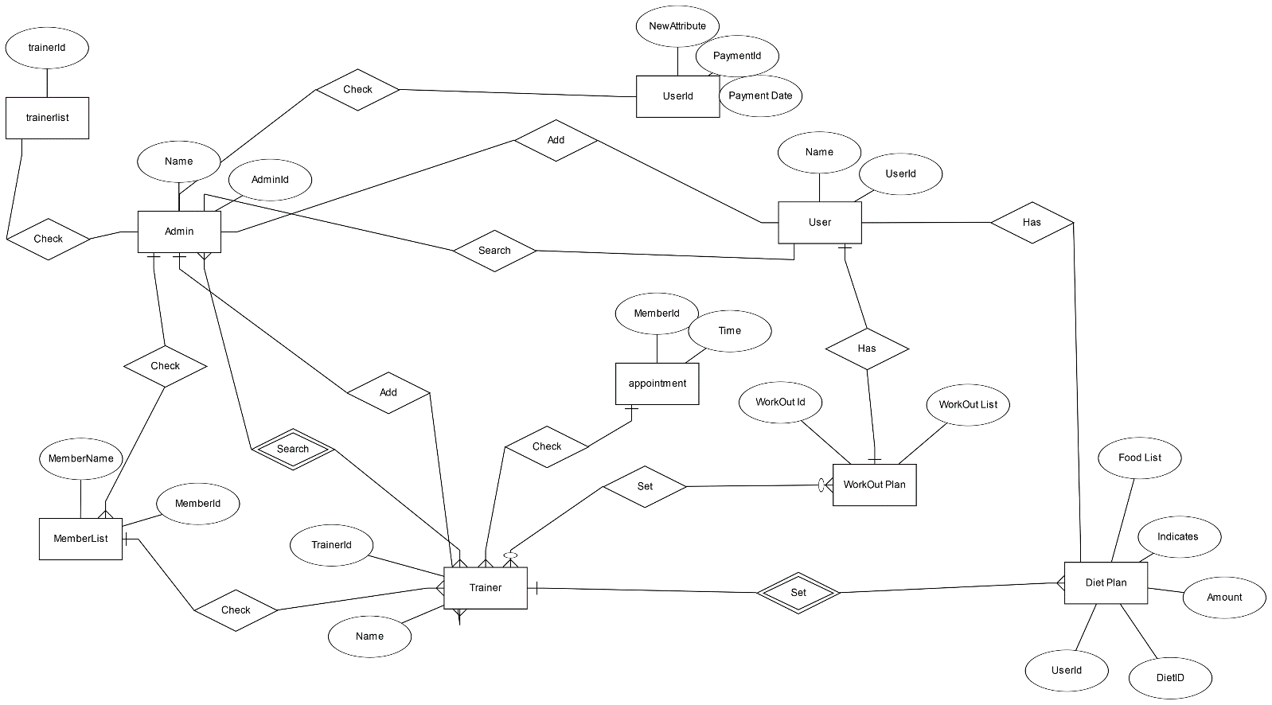

Fig:1 ER diagram of Gym Management System.

**Tools Used:**

To develop this project, we have used the following:

Front end:

• HTML: HTML is used to create and save web document. E.g. Notepad/Notepad++

• CSS : (Cascading Style Sheets) Create attractive Layout.

Back end:

• PHP: Hypertext Preprocessor (PHP) is a technology that allows software developers to create dynamically generated web pages, in HTML, XML, or other document types, as per client request. PHP is open source software.

• MySQL: MySql is a database, widely used for accessing querying, updating, and managing data in databases.

• XAMPP Server.

**System Images against the Specification:**

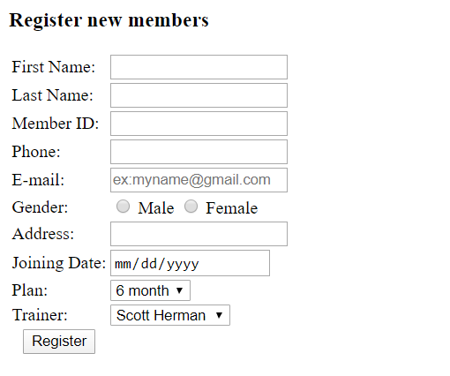

Fig:2 New Member registration form.

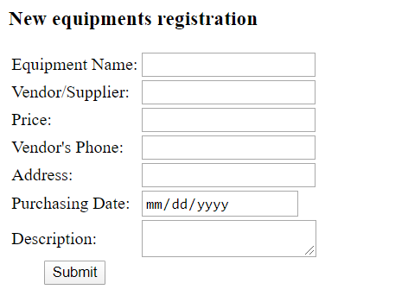

Fig:3 New Equipment registration form.

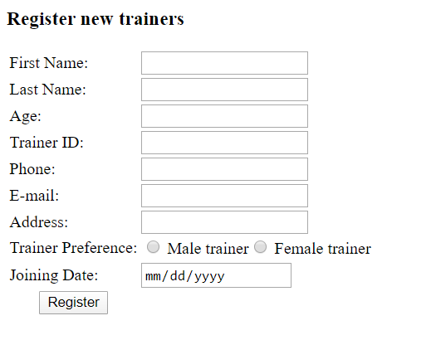

Fig:4 New Trainer registration form.

**Impact of this Project:**

Gym management system is an easy-to-use gym and health club membership management system. It helps you keep records of your members and their memberships, and allows easy communication between you and your members. Gym Management system is also feature-packed, helping you in the management and growth of your club.

**Limitations and Possible Future Improvements:**

The project has been developed in a very short period of time and all efforts have been taken so that this project is very efficient in its execution there still exists some scope of improvement in our project. Application of the project can be done more attractively. Database management and all maintenance module can be updated which helps the administrator. More security measures can be taken. There are also few features which can be integrated with this system to make it more flexible.

|  |  |  |  |  |  |
| --- | --- | --- | --- | --- | --- |
| **CO1 and CO3 Evaluation: Project Report Evaluation** | | | | | |
| **Project Proposal**  **(5)** | **Background**  **Study**  **(5)** | **Requirement Analysis**  **(5)** | **Entity**  **Diagram**  **(5)** | **System Images**  **against the**  **Specification (5)** | **Total (25)** |
|  |  |  |  |  |  |
|  | | | | | |